***MINIPROJECT***

DESCRIPTION:AN APPPLICATION USING JDBC TO STORE AND RETRIVE INFORMATION ABOUT EMPLOYEES OF AN ORGANIZATION

***AUTHOR:ARCHANA G R***

***SOURCE CODE:***

package Adsproject;

import java.sql.Connection;

import java.sql.DriverManager;

import java.sql.PreparedStatement;

import java.sql.ResultSet;

import java.sql.Statement;

import java.util.Scanner;

public class javaMIniproject {

 static Connection con;

     static Statement stm;

    static Scanner sc=new Scanner(System.in);

    static void getConnection() throws Exception{

     try {

    Class.forName("com.mysql.cj.jdbc.Driver");

     con=DriverManager.getConnection("jdbc:mysql://[sql12.freemysqlhosting.net:3306/sql12331350](http://sql12.freemysqlhosting.net:3306/sql12331350)","sql12331350","nDytwNvrRp");

   stm=con.createStatement();

     }

     catch(Exception e)

     {

     System.out.println("Cant establish connection!!!!!");

     }

     }

static void addrecord() throws Exception{

System.out.println("ENTER EMPLOYEE'S ID: ");

int empno=sc.nextInt();

System.out.println("ENTER EMPLOYEE'S FIRST NAME:");

String fname=sc.next();

System.out.println("ENTER EMPLOYEE'S LAST NAME:");

String lname=sc.next();

System.out.println("ENTER DATE OF BIRTH(YYYY-MM-DD):");

String dob=sc.next();

System.out.println("ENTER JOIN DATE:");

String join=sc.next();

System.out.println("ENTER Department:");

String dept=sc.next();

System.out.println("ENTER DESIGNATION:");

String desg=sc.next();

System.out.println("ENTER BASIC SALARY:");

int sal=sc.nextInt();

System.out.println("ENTER EDUCATIONAL QUALIFICATION:");

String qualification=sc.next();

System.out.println("ENTER 1st LINE OF ADDRESS:");

String add1=sc.next();

   System.out.println("ENTER CITY:");

   String city=sc.next();

   System.out.println("ENTER PIN");

   int pin=sc.nextInt();

   System.out.println("ENTER PHONE NUMBER:");

   int phone=sc.nextInt();

String sql="insert into Employee_table values('"+empno+"','"+fname+"','"+lname+"','"+join+"','"+desg+"','"+dept+"','"+sal+"');";

String sql2="insert into Employee_Personal_Info values('"+empno+"','"+dob+"','"+qualification+"','"+add1+"','"+city+"','"+pin+"','"+phone+"');";

     stm.execute(sql);

     stm.execute(sql2);

   System.out.println("record added!!!");

}

static void displayall() throws Exception{

PreparedStatement ps2=con.prepareStatement("select * from Employee_table");

ResultSet rst=ps2.executeQuery();

System.out.println("Employee table:");

System.out.println("Empno       FULLNAME          DATE OF BIRTH       DESIGNATION        DEPARTMENT      NETSALARY");

while(rst.next())

{

int sal=Integer.parseInt(rst.getString(7));

int HRA=(sal*20)/100;

int DA=(sal*40)/100;

int it=((HRA+DA+sal)*10)/100;

int netsal=sal+HRA+DA+it;

System.out.println(rst.getString(1)+"     "+rst.getString(2)+"     "+rst.getString(3)+"    "+rst.getString(4)+"    "+rst.getString(5)+"               "+rst.getString(6)+"           "+netsal);

}

}

static void modifyrecord() throws Exception{

System.out.println("ENTER EMPLOYEE ID TO MODIFY RECORDS:");

String id=sc.next();

PreparedStatement ps2=con.prepareStatement("select * from Employee_table");

int flag=0;

ResultSet rst=ps2.executeQuery();

System.out.println("Record of employee id"+id+"\n");

while(rst.next())

{

String emp=rst.getString(1);

if(id.equals(emp))

{

System.out.println("DATA OF EMPLOYEE NUMBER "+emp+" IS:");

System.out.println(rst.getString(1)+" "+rst.getString(2)+" "+rst.getString(3)+" "+rst.getString(4)+" "+rst.getString(5)+" "+rst.getString(6)+" "+rst.getString(7));

System.out.println("\n\n");

System.out.println("SELECT Coloumn TO MODIFY");

System.out.println("DESGINATION     1");

System.out.println("DEPARTMENT      2");

System.out.println("BASIC SALARY     3");

System.out.println("\n\n");

System.out.println("ENTER YOUR CHOICE:");

int choice=sc.nextInt();

switch(choice)

{

case 1:

System.out.println("ENTER VALUE TO MODIFY:");

String des=sc.next();

String sql="update Employee_table set designation='"+des+"' where Empno="+id+";";

stm.execute(sql);

System.out.println("RECORD MODIFIED SUCCESSFULLY!!!!!");

flag=1;

break;

case 2:

System.out.println("ENTER VALUE TO MODIFY:");

String dep=sc.next();

String sql1="update Employee_table set dept='"+dep+"' where Empno="+id+";";

stm.execute(sql1);

System.out.println("RECORD MODIFIED SUCCESSFULLY!!!!!");

flag=1;

break;

case 3:

System.out.println("ENTER VALUE TO MODIFY:");

int salary=sc.nextInt();

String sql2="update Employee_table set salary='"+salary+"' where Empno="+id+";";

stm.execute(sql2);

System.out.println("RECORD MODIFIED SUCCESSFULLY!!!!!");

flag=1;

break;

default:

System.out.println("ENTER VALID CHOICE!!1");

}

if(flag==0)

{

 System.out.println("COULDNT MODIDY RECORD!!!!!!");

}

}

}

}

static void deleterecord() throws Exception{

try {

System.out.println("ENTER EMPLOYEE NUMBER TO DELETE RECORD:");

String empno=sc.next();

int check=0;

PreparedStatement ps2=con.prepareStatement("select * from Employee_table");

ResultSet rst=ps2.executeQuery();

 while(rst.next())

{

String emp=rst.getString(1);

if(empno.equals(emp))

{

System.out.println("DO YOU WANT TO DELETE THE RECORD OF EMPLYEE WHOSE EMPLOYEE ID IS: "+empno+" THE ENTER Y/y:");

String c=sc.next();

if(c.toUpperCase().equals("Y"))

{

String sql="delete from Employee_table where Empno="+empno+";";

String sql1="delete from Employee_Personal_Info where Empno="+empno+";";

stm.execute(sql);

stm.execute(sql1);

System.out.println("RECORD IS DELETED!!!!");

check=1;

break;

}

}

}

 if(check==0)

 {

 System.out.println("couldnt find employee id "+empno+"......");

 }

}

catch(Exception e)

{

System.out.println("COULDNT DELETE RECORD!!!!!");

}

}

static void displayonerecord() throws Exception{

System.out.println("ENTER EMPLOYEE NUMBER TO DISPLAY RECORD:");

String empno=sc.next();

PreparedStatement ps2=con.prepareStatement("select * from Employee_table");

ResultSet rst=ps2.executeQuery();

 while(rst.next())

{

String emp=rst.getString(1);

if(empno.equals(emp))

{

System.out.println("EMPLOYEE NO:"+rst.getString(1)+"\nEMPLOYEE NAME: "+rst.getString(2)+" "+rst.getString(3)+"\nJOIN DATE: "+rst.getString(4)+"\nDESGINATION: "+rst.getString(5)+"\nDEPARTMENT: "+rst.getString(6)+"\nSALARY:"+rst.getString(7));

}

}

 PreparedStatement ps3=con.prepareStatement("select * from Employee_Personal_Info");

 ResultSet rstm=ps3.executeQuery();

while(rstm.next())

{

String id=rstm.getString(1);

if(id.equals(empno))

{

System.out.println("DATE OF BIRTH:"+rstm.getString(2)+"\nEDUCATIONAL QUALIFICATION:"+rstm.getString(3)+"\nADDRESS:"+rstm.getString(4)+"\nCITY"+rstm.getString(5)+"\nPIN:"+rstm.getString(6)+"\nPHONE:"+rstm.getString(7));

}

}

}

public static void main(String[] args) throws Exception

{

getConnection();

System.out.println("\t\t\t\t\t***************************************************");

System.out.println("\t\t\t\t\t*****************WELCOME***************************");

System.out.println("\t\t\t\t\t***************************************************");

     System.out.println("\n\n\n\n");

     System.out.println("\t\t\t\tMAIN MENU");

     System.out.println("ADD RECORD\t\t\t\t\t\t[1]");

     System.out.println("MODIFY RECORD\t\t\t\t\t\t[2]");

     System.out.println("DELETE RECORD\t\t\t\t\t\t[3]");

     System.out.println("DISPLAY ONE RECORD\t\t\t\t\t[4]");

     System.out.println("DISPLAY ALL RECORD\t\t\t\t\t[5]");

     System.out.println("Exit\t\t\t\t\t\t\t[6]");

    while(true){

     System.out.println("ENTER YOUR CHOICE:");

    int choice=sc.nextInt();

    System.out.println("\n\n");

switch(choice)

{

case 1:

addrecord();

System.out.println("\n\n\n");

break;

case 2:

modifyrecord();

       System.out.println("\n\n\n");

break;

case 3:

{

deleterecord();

System.out.println("\n\n\n");

      break;

}

case 4:

displayonerecord();

break;

case 5:

displayall();

break;

case 6:

System.out.println("\n\n\n");

System.out.println("Process terminated...........");

Thread.sleep(100);

System.out.println("************PROGRAM EXITED!!!!!!!!!*****************\n\t\tTHANKYOU FOR USING THIS APPLICATION");

System.exit(0);

 }

}

}

}

OUTPUT:

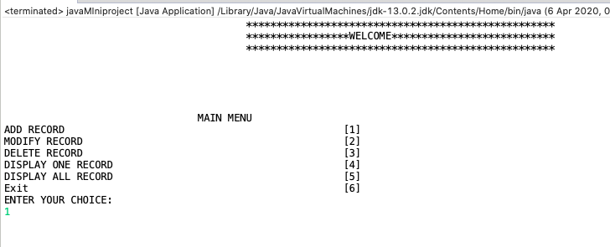***Main menu display:***

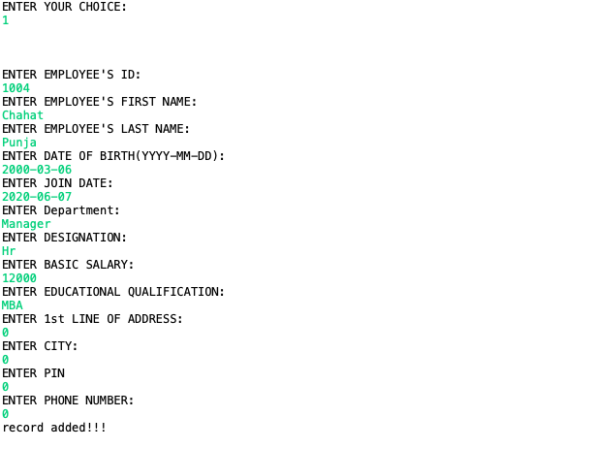

***INSERT OPTION DISPLAY-ADDING RECORD***:

***Modify record display:***

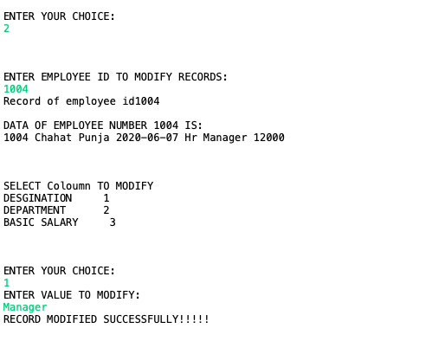

***DELETE RECORD DISPLAY:***

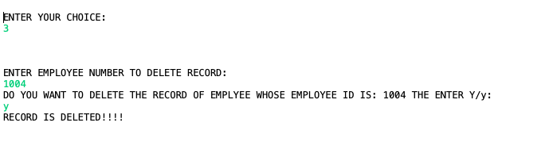***IF ENTERED ID IS PRESENT IN DATA:***

***IF ENTERED ID IS NOT PRESENT IN DATA:***

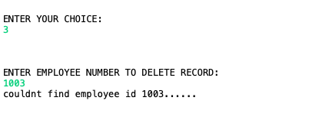

***DISPLAY ONE RECORD:***

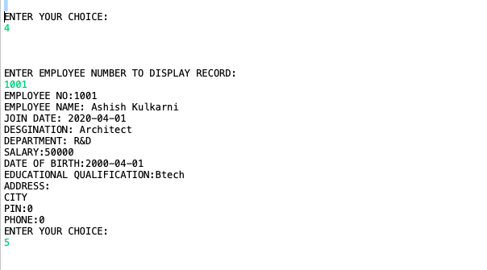

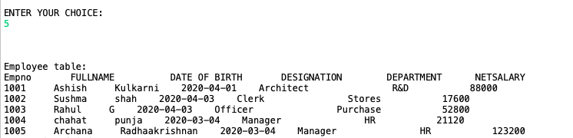

***DISPLAY ALL RECORD:***

***Exit:***

